

# Silverlight Contrib – Alpha 1 Documentation

Last Modified: September 3rd, 2008

Contents

Silverlight Contrib – Alpha 1 Documentation 1

Silverlight Contrib Controls Overview 3

Color Picker Control 4

Control Description 6

Silverlight Contrib Utilities Overview 7

Contributors 8

# Silverlight Contrib Controls Overview

* Color Picker
* Cool Menu
* Slider Gauge
* Star Selector

## Color Picker Control

**Overview**The Color Picker Control allows for the selection of hex color values as you would an many popular graphics editor applications.

**Default Look**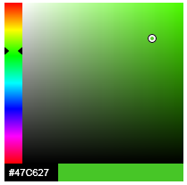

**Namespace**SilverlightContrib.Controls.ColorPicker **Remarks**

**Examples**

## Control Description

**Overview**Control Overview Here

**Default Look**<< Default Control Image >>

**Namespace**<< Control Namespace >> **Remarks**<< Default Control Image >>

**Examples**<< Default Control Image >>

# Silverlight Contrib Utilities Overview

* SharpZipLib

# Contributors

A Special Thanks goes out to all who have helped to make this project a success! This project would not be possible without you!

Page Brooks  
<http://pagebrooks.com>

Rob Houweling  
<http://web-snippets.blogspot.com>